

WILLETTON SENIOR HIGH SCHOOL

**YEAR 12 PHYSICS 2021**

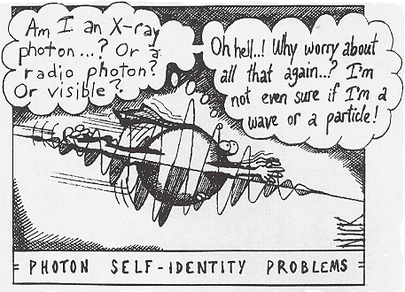

**TASK 8**

**TEST 4: Power Generation, Wave Particle Duality & Quantum Theory**

**Solutions**

**MARKS**

**/55**

**Instructions:**

1. Answer **all** the questions in the spaces provided.
2. Where appropriate, for numerical answers express your answers correct to

3 significant figures. Estimates should be given to 2 significant figures.

1. Not all question carry equal number of marks. The marks available for each question are shown.

4. Show working out steps neatly, logically and clearly to score full marks.

5. You may only use a scientific calculator.

6. **Write with a blue or black ink pen.** You may use a lead pencil to draw

diagrams.

Question 1. (4 marks)

Light is said to exhibit dual properties.

(a) What is meant by the dual nature of light? (2 marks)

**Light displays the properties of waves (1) and the properties of particles (1).**

(b) Give one example of each of the properties of light that supports its dual nature. (2 marks)

Example 1: **One** of the following

**Reflection, refraction, dispersion, polarisation, diffraction, interference (1)**

Example 2: **One** of the following

**Emission/absorption spectra, black body radiation, photoelectric effect (1)**

Question 2. (4 marks)

Both the Sun and an electric light globe emit a continuous spectrum of visible light. However, there are dark lines in the Sun’s spectrum (called Fraunhofer Lines) which are not seen in the spectrum of the light globe. Explain how these lines occur.

**As light leaves the sun, certain frequencies are absorbed by the gases in the solar atmosphere. (1)**

**The lines correspond to the energy absorbed by electrons in the gas atoms to raise them to a higher energy state. (1)**

**This will remove those frequencies from the continuous spectrum, (1)**

**resulting in the dark lines (Fraunhofer lines). (1)**

Question 3. (9 marks)

The primary coil of a 9.00 kW step-up transformer is drawing power from a generator. The primary coil draws a peak current of 25.0 A. The secondary coil of the transformer has 555 turns of wire and produces a peak voltage 5.40 kV. Assume the transformer is ideal.

1. Determine the ratio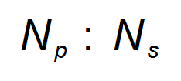in its simplest form. (3 marks)

|  |  |
| --- | --- |
| **Description** | **Marks** |
|  | 1 |
|  | 1 |
|  | 1 |
| **Total** | 3 |

1. Determine the number of turns of wire in the primary coil. (1 mark)

|  |  |
| --- | --- |
| **Description** | **Marks** |
|  | 1 |
| **Total** | 1 |

1. Determine the RMS current on the secondary side of the transformer. (3 marks)

|  |  |
| --- | --- |
| **Description** | **Marks** |
|  | 1 |
|  | 1 |
|  | 1 |
| **Total** | 3 |

1. State and explain one (1) possible source of power loss within non-ideal transformers.

(2 marks)

|  |  |
| --- | --- |
| **Description** | **Marks** |
| Either  Eddy currents in the iron core OR Resistive heat loss in wires of secondary coil | 1 |
| Eddy currents in the iron core  The alternating magnetic field experienced by the iron core results in the formation of eddy currents.  These eddy currents create heat losses due to the resistance in the iron core. | 1 – 2 |
| Resistive heat-loss in wires of secondary coil  Wires, no matter which property or dimension all have some sort of resistance. Effectively they act as a resistor and therefore have some amount of power loss (voltage drop) across them. | 1 – 2 |
| **Total** | 3 |

Question 4. (4 marks)

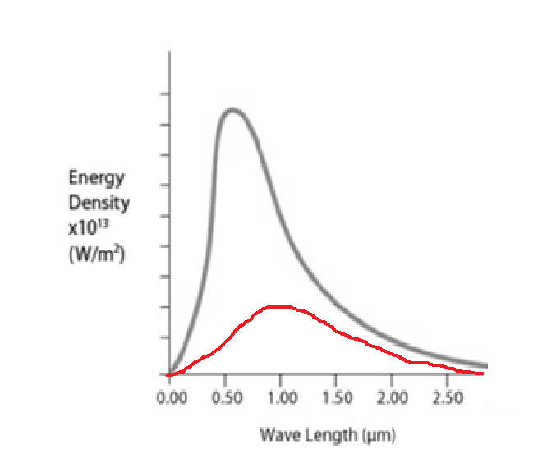Below is a typical black-body curve at a certain temperatur

(a) What are the characteristics of an ideal black body? (2 marks)

**A perfect absorber of radiation (1)**

**And a perfect emitter of radiation. (1)**

(b) If the temperature of the black-body is halved, sketch on the above graph the shape of the new curve. (2 marks) **Peak wavelength will increase. (1)**

**Total energy output decreases. (1)**

Question 5. (4 marks)

An AC generator produces a peak voltage of 3.18 kV. The coil is circular with a diameter 26.0 cm and sits in a magnetic field of 9.00 × 10-2 T.

The graph below shows the variation of voltage generated with time.

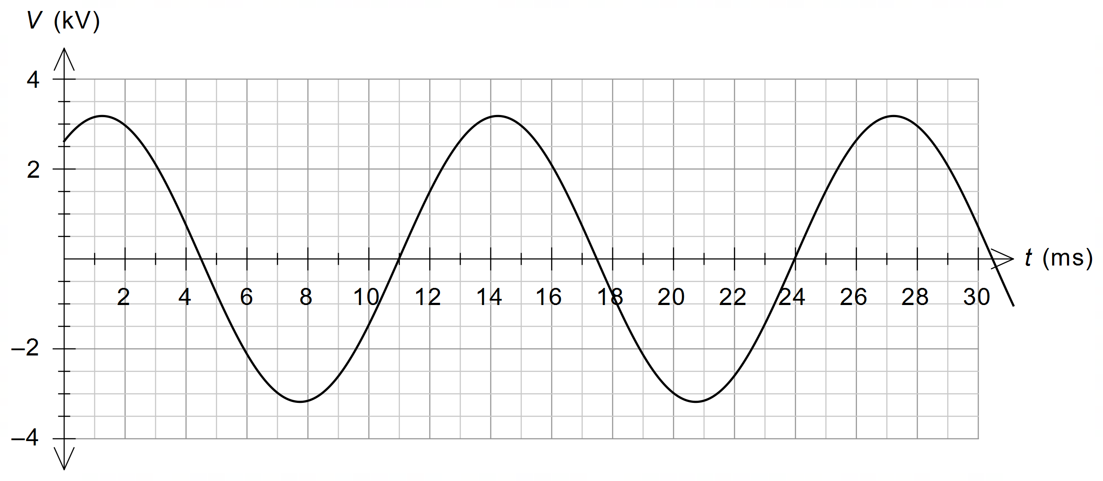

Use this information to **estimate** the number of turns of wire in the generator coil.

Give your answer to an appropriate number of significant figures.

|  |  |
| --- | --- |
| **Description** | **Marks** |
|  | 1 |
| Number of turns is 1400 | 2 |
| Answer to 2 sig figs | 1 |
| **Total** | 4 |

Question 6. (4 marks)

A non-ideal intermediate transformer accepts electrical energy from a long-distance transmission line at a rate of 270 MW and has an output voltage of 13.0 kV. After the intermediate transformer, electrical energy is delivered to a local transformer at a rate of 231 MW and 11.5 kV along a 2.50 km long line, having a resistance rating of 0.0750 Ω km–1. Determine the percentage efficiency of the intermediate transformer. Show working.

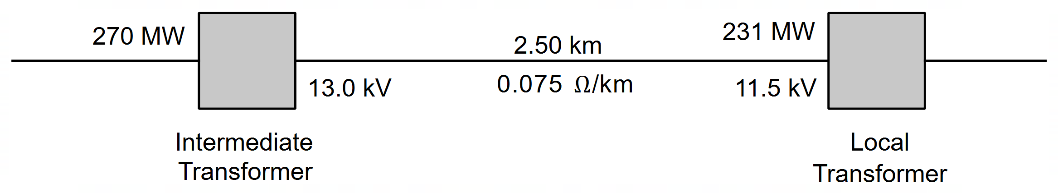

|  |  |
| --- | --- |
| **Description** | **Marks** |
|  | **1** |
|  | **1** |
|  | **1** |
|  | **1** |
| **Total** | **4** |

Question 7. (6 marks)

1. Derive the expression

𝝀 = $\frac{h}{√2mqV}$

for a particle of mass m and charge q, which is being accelerated through a potential difference V. (4 marks)

**Ek = qV = $\frac{1}{2}$ m $v^{2}$ (1)**

**v = √ 2Ek/m**

**= √ 2qV/m (1)**

**𝝀 = $\frac{h}{\sqrt{p}}$**

**= *h*  (1)**

**m. √ 2qV/m**

**𝝀 = $\frac{h}{√2mqV}$ (1)**

**(Any other logic ok)**

1. If you double the kinetic energy of a particle, how does the de Broglie wavelength change? Show your working. (2 marks)

**λ = $\frac{h}{p}$ = *h* = *h__*  (1)**

**√ 2mqV √ 2mEk**

**If Ek doubled λ = *h .***

**√ 2m2Ek**

***Hence* 𝝀 is reduced by a factor of 1/√ 2 ( 0.707 λ1.) (1)**

Question 8. (9 marks)

The figure at right illustrates some of the valence electron energy levels in a gaseous atom of a particular element. The energies of the levels are given in electron volts (eV).

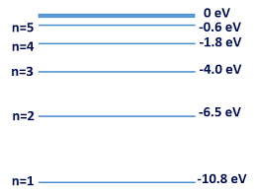

(a) The valence electron of the atom is in the lowest energy level shown. What is the ionisation energy of the atom in joules? (2 marks)

**Ionisation energy = 10.8 eV (1)**

**= 10.8 x 1.6 x 10-19 J**

**= 1.73 x 10-18 J (1)**

(b) State two physical processes by which an electron in the ground state can move to a higher energy level. (2 marks)

**Any two of the following points**

* **absorption of a photon of energy exactly equal to the energy level difference**
* **bombardment by an electron with sufficient KE to excite the atom**
* **thermal excitation whereby if the sample of gas is hot enough then atomic collisions may be energetic enough to excite atoms**

A cold gaseous sample of the element is bombarded by electrons of energy 9.5 eV and observed to emit electromagnetic radiation.

(c) Show on the diagram above the energy level transitions that cause this emission of electromagnetic radiation. (2 marks)

**9.5 eV can excite atoms up to level n = 4 (1)**

**6 emission lines (1)**

(d) Calculate the longest wavelength of the emitted electromagnetic radiation.

(3 marks)

**Longest wavelength of radiation = smallest energy**

**= 2.2 eV (n = 4 to 3) (1)**

**E = hc/λ ⇒ λ = hc/E**

**= (6.63 x 10-34)(3 x 108)/(2.2 x 1.6 x 10-19) (1)**

**= 5.65 x 10-7** **m (1)**

Question 9. (5 marks)

Physics students studying interference set up a double slit experiment using a 615 nm laser as shown below.

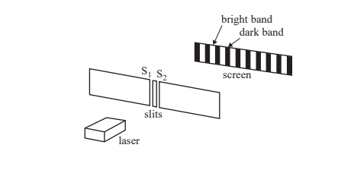

The power output of the laser is 5.03 x 10-3 Js-1.

(a) Calculate the number of photons leaving the laser each second. (3 marks)

Energy in one photon is

**E =**

**= x 3 x108 (1)**

**= 3.23 x 10-19 J (1)**

**Number of photons =**

**= 1.56 x 1016 (1)**

A section of the interference pattern observed by the students is shown below. There is a bright band at point C, the centre of the pattern.



(b) Explain why point C is a bright band and not a dark band. (2 marks)

**The distance travelled by each of the light waves is the same (1)**

**Therefore the waves will be in phase and will interfere constructively (1)**

10. (6 marks)

The diagram below shows a smoke alarm unit that contains a light-emitting diode (LED) and a photocell. When smoke particles enter the unit they reflect some of the monochromatic light from the LED onto the photocell. This causes the metal in the photocell to release electrons, causing an alarm to sound. The metal used in the photocell has a work function of 1.55 eV.

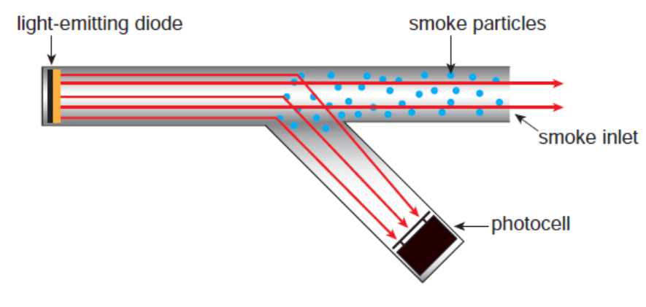

(a) Calculate the threshold frequency for the metal used in the photocell. (3 marks)

**W = 1.55 eV = 1.55 x 1.6 x 10-19 J**

**= 2.48 x 10-19 J. (1)**

**EK = hf - W**

**Ek = 0 at the threshold frequency. (1)**

**∴ hf = W**

**⇒ f = $\frac{2.48 x {10}^{-19}}{6.63 x {10}^{-34}}$**

**= 3.74 x 1014 Hz. (1)**

(b) The number of smoke particles in the smoke alarm unit increases. Use the concept of photons to explain the effect of the increased number of smoke particles on the **number** and **energy** of the electrons released in the photocell. (3 marks)

**More smoke particles,**

**⇒ more photons scattered onto photocell, (1)**

**⇒ more photoelectrons emitted, (1)**

**⇒ as each photon has the same energy, the energy of the photelectrons would not change. (1)**